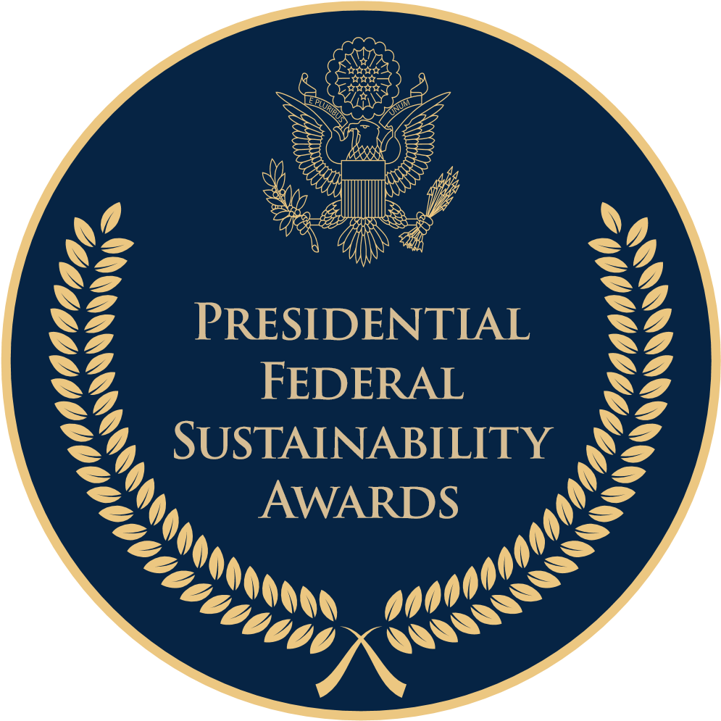 |  | 2023 Presidential Federal Sustainability Awards  Nomination Form
Nomination Deadline: June 30, 2023

Instructions
- Please review the nomination guidelines for information on award categories, eligibility and detailed instructions for completing this nomination form.
- Nominations should be based on actions, efforts, accomplishments, and impact toward advancing the Administration’s Federal sustainability goals during the period of January 21, 2021 through the nomination deadline (June 30, 2023).

Step 1:
- You must complete all sections of the nomination form. Partial submissions will not be accepted.
- Do not alter the structure or format of the nomination form, including removing fields, changing fonts or font sizes.
- Content must not exceed the following word limits:
  - Summary Statement: Max 50 words
  - Nomination Overview: Max 750 words
  - Outcomes and Achievements: Max 750 words
  - Impact and Innovation: Max 500 words
- Nominations may include a limited number of hyperlinks to publicly available materials relevant to the nomination, e.g., a program website, project overview, agency announcement, or press release. Judges will have the discretion to determine whether or not to consider supplemental materials in the evaluation.

Step 2: Submit your nomination for internal review, according to your agency’s process. Note that the agency Chief Sustainability Officer (or equivalent if no CSO exists) must submit all official agency nominations to CEQ. Individual nominations submitted directly to CEQ cannot be considered.

For information regarding your agency’s internal awards submission process, please contact your agency sustainability leads.

For questions or clarification regarding the instructions or nomination form, contact sustainability.awards@ceq.eop.gov.

2023 Presidential Federal Sustainability Awards
Nomination

 |  |  |  |  |  |  |  |  | Date:
 |  |  |  |  |  |  |  |  |  |  | MM |  | DD |  | YYYY
 | 1. Nominee
 | Agency:
 | Nominee Name/Title:
 | Facility Name and Location: |  |  |  | (Use N/A if not relevant to the nomination)
 | Nomination Type:
 | ☐ |  | Program |  |  |  | ☐ | Project
 | ☐ |  | Facility/Installation |  |  |  | ☐ | Team
 | ☐ |  | Individual
 | Award Category (may select up to two):
 | ☐ |  | Advancing Carbon-Free Electricity |  |  |  | ☐ | Advancing Environmental Justice
 | ☐ |  | Electrifying the Federal Fleet |  |  |  | ☐ | Building a Climate-Ready Workforce
 | ☐ |  | Decarbonizing Federal Buildings |  |  |  | ☐ | Leveraging Partnerships
 | ☐ |  | Building Sustainable Supply Chains |  |  |  | ☐ | Investing in Climate Smart Buildings
 | ☐ |  | Advancing Climate Adaptation & Resilience |  |  |  | ☐ | Buying Clean
 |  | 2. Nomination Point of Contact
 |  | Name and Title:
 |  | Bureau/Office/Program:
 |  | Contact: |  |  | Phone:
 |  |  |  |  | Email:
 |  | 3. Agency Review and Approval
 |  | Agency Chief Sustainability Officer (CSO) Approval
 |  | CSO Name:
 |  | ☐ | Agency CSO certifies the nomination has been approved for submission
 |  | Facility Compliance: For nominations associated with a facility, the agency affirms it has reviewed the facility’s compliance information in EPA’s Enforcement & Compliance History Online (ECHO) within 30 days of this nomination and:
 |  | ☐ |  | Concurs with all of the information presented
 |  | ☐ |  | Does not concur with all of the information presented
 |  | ☐ |  | Not applicable to the nomination

4. Team Member Information

Identify Team Members (For a Total of 6), including Names, Titles, Offices/Bureaus:
Team Lead(s):

Delete text in italics and insert information here.

Other Key Team Member(s):

Delete text in italics and insert information here.

5. Nomination Narrative
Nomination Narrative in each of the text areas below, following the word limits pred.
Summary Statement (Max 50 words)
Succinctly describe why you are making this nomination for a Presidential Federal Sustainability Award. Highlight leadership, innovation, impact, key results, and other factors that distinguish the nominee.

Delete text in italics and insert statement here.

Nomination Overview (Max 750 words)
Describe the program, project, facility, team, or individual you are nominating and their role in advancing Federal sustainability in the relevant award category or categories. Narrative should include:
- Background that illustrates objectives, scope, scale, and size of the program/project/initiative.
- Relevant dates and timelines, for example: program/project/initiative inception, launch, and completion date(s).
- Specific elements and criteria for the award category/categories in the Nomination Guidelines.
- A description of any cross-agency, cross-government, or other key coordination and collaboration in connection with the program/project/initiative.

Delete text in italics and insert narrative here.

Leadership and Innovation (Max 500 words)
Describe how the nominee has demonstrated initiative, creativity, and/or early action on sustainability goals and priorities. This may include, where applicable:
- How the nominee exemplifies "leading by example" in the category
- Contribution to reinvigorating sustainability within the agency
- Examples of developing or implementing new and/or leading approaches and solutions, or where the nominee is “first of its kind” within an industry, agency, or government-wide
- Use of new, innovative, or cutting-edge technologies
- Examples where the nominee has catalyzed or inspired action beyond their specific program/project/initiative, for example: the nominee contributed to a whole-of-government approach; other agencies, programs, teams, individuals, or external partners have replicated or taken action as a result of the nominee’s work; etc.

Delete text in italics and insert narrative here.

Impact and Outcomes (Max 750 words)
Describe the nominee’s impact, results, and achievements, which can include projected future outcomes. Narrative should include, where applicable:
- How the nominee has advanced Federal sustainability and, in particular, the goals of Executive Order 14057, Catalyzing Clean Energy Industries and Jobs Through Federal Sustainability
- Quantifiable impacts, for example: energy, water, or GHG reductions; number of employees, partners, or community members engaged; budget savings (bulleted list preferred, can include projected results)
- Integration with other E.O. 14057 goals, and ways this effort advances complementary Administration priorities, for example: environmental justice, equity, permitting improvement, nature-based solutions, plastic waste reduction, or addressing PFAS.

Delete text in italics and insert narrative here.

